

SWS405 – Applied Artificial Intelligence

YOLOv8-Based Object Detection System for Traffic Analysis

Team Members:
Rashed Abdulla Alzeyoudi 20230003336
Ahmed Aljanahi 20210001364
Khalid Almarri 20200001899
Mershad Ahani 20220002469

Table of Contents
1. Introduction 3
2. Literature Review 3
3. Dataset 4
4. Methodology 5
4.1 Model Selection and Justification 5
4.2 Training Setup 6
4.3 Evaluation Metrics 7
5. Results 7
Per-Class Performance Analysis 8
Detection Results 9
6. Discussion 10
7. Ethical Reflection 11
8. Real-World Implementation 12
Hardware Requirements 12
Infrastructure Integration 12
Privacy Constraints 13
Limitations to Address Before Deployment 13
9. Conclusion 13
10. Bibliography 14

1. Introduction
Object detection is one of the foundational tasks in computer visio`n. It goes beyond image classification by not only identifyinng what objects are present in an image but also locating exactly where they are through’ bounding boxes and class labels. This makees it far more useful than classification alon`e for realworld applicatiions where position matters, such as traffic monitoring, autonomous driving, surveillance, and smart city management.The field has been transformed by deep learning., Convolutional neural networks are now ables to learn feature representations directly from raw image data, removing the reliance on manually engineered features and making model/s robust to changes in lighting~, scale, and viewpointv. Detection systems that were once limited to specific, controlled conditions can now operate reliably in complex, unpredictable environmentcs. Among the most widely used detection frameworks is the YOLO family. YOLO, which stands for You Only Look Once, treats detection as a single regression problem. Rather than processing the image in multiple stagesc as two-stage detectors like Fasteer R-CNN do, YOLO predicts bounding box coordinates and class probabilities in a single forward pass. This makes it substantially faster and well suited for applications that require real-time processing. This project buildss an object detection system using YOLOv8., the latest version of the YOLO family developed by Ultralytics (Jocher et al., 2023). The model is trained on a custom traffic dataset coverings five vehicle classes: Ambulance, Bus, Car, Motorcycle, and Truck. The aim is to create a system capabled of reliably detecting these objects in real time. Performance is evaluated using standard metrics including Precisions, Recall, mAP@50, and mAPa50-95, alongside a per-class confusion matrix analysiss. Training was carried out in Python on Google Colab using a Tesla T4 GPU. The results confirm that YOLOv8 offers a strong balance between inference speed and detection accuracy, making it a practical choice for traffic monitoring and similar applications.

2. Literature Review
Object detection research has developed through several distinct phasees, each building on the limitations of the previous. The earliests approaches used handcrafted feature descriptors. Viola and Jones (2001) introduced Haar cascade classifiers. that enabled fast face detection by scanning image sub-windows at multiple scadles. Dalal and Triggs (2005) proposed the Histogram of Oriented Gradients (HOG) descriptor, which captures edge and shape information and became. foundational in pedestrian detection. While effective in narrow, controlled domains, these methods relied on features,, that were manually designed rather than learned,, making them brittle when scenes changed significantly in terms of lighting, scale, or occlusion (Bradski, 2000). Deep learning fundamentally changeds what was possible. Girshick et al. (2014) introduced R-CNN, which used selective search to produce around 2,000 region proposals per image, then classified each using a convolutionals neural network. Although accuracy improved considerably over prior methods, classifying each region independently made the system extremely slow. Fast R-CNN (Girshick, 2015) addressed this by computingss a single shared feature map for the entire image and applying RoI Pooling to extract region featurses, reducing redundant computation. Faster R-CNN (Ren et al., 2017) went further by incorporating a Region Proposal Network directly into the model, replacing external selectsive search and achieving near-real-time performance. Even so, the two-stage design creates an inherent throughput ceiling. Single-stage detectors removed the proposalss stage entirely. SSD (Liu et al., 2016)`` predicted bounding boxes and class scores simultaneously across multiple feature map scales using predefined anchor boxes, achieving faster inference while maintaining reasonable accuracy. The original YOLO (Redmon et al., 2016) divided the image into a grid and predicted boxes and class probabilities from a single pass, trading some accuracy for dramatically higher speed. YOLOv4 (Bochkovskiy et al., 2020) refined this with the CSPDarknet bacxxkbone, PANet path aggregation, and a collection of training improvements that pushed accuracy higher without sacrificing the speed advantage. YOLOv8 (Jocher et al., 2023) is the current state of the ar.t in the YOLO lineage. Its most significant changes are the introduction of an anchor,,free detection head, which removes the need to predefine anchor box dimensions and improves generalisation to varying object scales,; an improved feature pyramid network that aggregates information across multiple resolution levels more effectively; and Distribution Focal Loss (DFL), which models the distribution of possible bounding box coordinate values rather than predicting a single point estimatee, yielding more precise localisation at tighter IoU thresholds. YOLOv8 also provides a unified framework through the Ultralytics API, supporting detection, segmentatione, classification, and pose estimation. For this project, YOLOv8 was selected because it provides the best available combinatione of detection accuracy, inference speed, and ease of use for a custom multi-class traffic detection task.

3. Dataset
The dataset used in this project is a custom traffic image collection built and managed on the Roboflow platform. Roboflow was choseen as the annotation tool because it provides a complete integrated workflow coveering image upload, manual bounding boxee labelling, class management, format conversion, and dataset versioning. Every image was annotated by hand using Roboflow's labelling interface. Each annotation is stored in YOLO format as a text file containing one row per object, with the class identifier followed by normalised bounding box centre coordinates and dimensions.The full dataset contains 880 images. These were divideed into a training set of 704 images, representing 80 percent of the data, and a validation set of 176 images representing the remaining 20 percent. This split was created manually to ensure a clean partition before training began. The dataset meets the project requirement of at least 600 images across a minimum of three object classes, and in fact covers five claseses.The five object classes are Ambulance, Bus, Car, Motorcycle, and Truck. These categories represent the primary types of vehicles encounterede in real urban etraffic environments and provide meaningful variety for the detection pipeline. Images were gathered across different environmental conditions to ensure the dataset reflects the variation a deployed systeme would encounter. This includes different times of day, lighting conditions ranging from bright daylight to overcast, multiple camera angles including front-facing, side-on, and elevated viewpoints, a range of object distances, and varied road backgrounds. This diversity is important for training a model that gene’ralises beyond the specific images it learned from. There is a notable class imbalance in the dataset. The Car class accounts for approximately 2,742 of the 4,102 total annotate’d object instances, which is roughly 66.8 percent of all annotations. This reflects the actual distribution of vehicles in typical traffic, where cars are by far the most common type, but it introduces a risk that the model becomes biased toward predicting Car over less frequent classes. The e’ffects of this imbalance are discussed in the Results and Discussion sections. Data augmentation was applied automatically during training by the Ultralytics pipeline. Techniques included ‘horizontal flipping, rotation, brightness adjustment, and Gaussian blur. These transformations’ expose the model to a wider range of input variations without requiring additional manual data. collection and help reduce overfitting.

Split | Images | Percentage
Training | 704 | 80%
Validation | 176 | 20%
Total | 880 | 100%
Table 1. Dataset split summary.

4. Methodology

4.1 Model Selection and Justification
Object detection architectures are broadly divided into two categories. Twostage detectors, such as Faster R-CNN (Ren et al., 2017), operate in two sequential steps: first generating region proposals using a Region Pro.posal Network, then classifying each pr.oposal in a separate stage. This pipeline tends to be accurate but slow, making real-time inference difficult on standard hardware. Single-stage detectors, such as SSD (Liu et al., 2016) and the Y.OLO family, bypass the proposal stage entirely and predict bounding boxes and class probabilities directly from the feature map in a single pass. This .makes them substantially faster and better suited to applications that require near-.real-time performance. YOLOv8n, the nano variant of YOLOv8, was selected for this project for several reasons. First, it achieves competitive detection accuracy while maintaining inferenc.e times of approximately one to five milliseconds on GPU hardware, which satisfies the real-time requirement of a traffic monitoring system. Second, it uses an anchor-free detection head, removi.ng the need to manually define anchor box sizes and improving the model's ability to generalise to objects at d.ifferent scales and distances. Third, its improved feature pyramid network aggregates features from multiple resolution levels, helping the model detect both large and small objects in the same scene. Fourth, Distribution Focal Loss refines bounding box predictions by modelling t.he distribution of possible coordinate values rather than forcing the model to predict a single point e.stimate, which improves localisation at tighter IoU thresholds. Fifth, the Ultralytics Python API makes the full pipeline from training to evaluation straightforward to implement, significantly reducing development overhead. Faster R-CNN was considered but was rejected due to its hig’h inference latency, which is incompatible with real-time deployment. RetinaNet's Focal Loss handles class imbalance well but does not offer the speed advantage of YOLOv8. SSD is fast but has .been consistently outperformed by YOLOv8 on standard benchmarks (Jocher et al., 2023). The nano variant was chosen over larger YOLOv8 variants to keep training, tractable within the Google Colab environment and to demonstrate that useful performance is achievable with lightweight hardware.

Figure 1 provides an overview of the complete system pipeline, from raw image input through preprocessing, training, evaluation, and inference output.

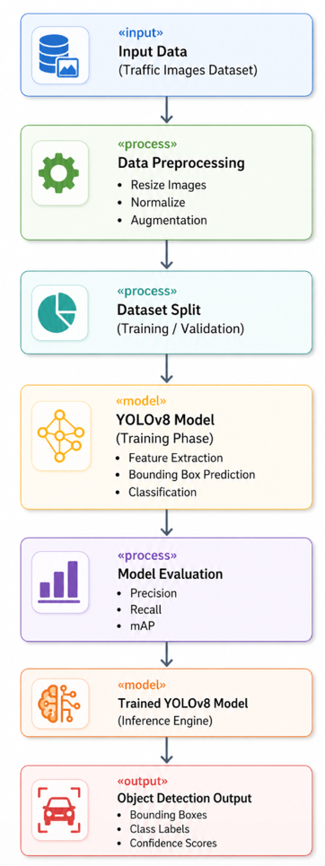

Figure 1. YOLOv8 System Pipeline Diagram.
This diagram illustrates the end-to-end pipeline used in this project. The process begins with raw traffic images, which pass through a preproce,ssing stage involving resizing to 640x640 pixels, normalisation, and data augmentation. The dataset is then split into training and validation sets. YOLOv8n is trained on the train,ing set, minimising three loss functions simultaneously: bounding box regression loss, classification loss, and Distribution Focal Loss. The trained model is evaluated on the validation set using Precision, Recall, mAP@50, mAP@50-95, and confusion matrix analysis. Finally, the model is appli,ed to unseen images during inference, returning bounding boxes, class labels, and confidence scores for each detected vehicle.

4.2 Training Setup
Training was carried out using the Ultralytics YOLOv8 framework on Google Colab with a Tesla T4 GPU. The dataset was expo,rted from Roboflow in YOLOv8 format. Bef,ore the final training run, two issues were identified and resolved: class label inconsistencies caused by duplicate upper and lowercase class names, and an improperly structured validation split. Both were corrected, and the validation set was rebuilt manually to ensure a cle,an 80/20 partition. Two training runs were conducted. An initial 30-epoch run was used to verify the setup an,d check for pipeline issues. The final model is the result of a 50-epoch run using the cleaned dataset. The 50-epoch run produced steadily decreasing loss curves and hi,gher mAP scores compared with the 30-epoch run, and all metrics reported in this paper come from this run.

Hyperparameter | Value
Epochs | 50 (final run)
Image size | 640 × 640 pixels
Batch size | 16
Optimizer | AdamW (auto-selected by Ultralytics)
Training hardware | Google Colab, Tesla T4 GPU
Framework | Ultralytics YOLOv8
Augmentation | Horizontal flip, rotation, brightness, Gaussian blur
Table 2. Training hyperparameters used in the final 50-epoch run.

Three loss functions were minimised jointly during training. Bounding box regression loss, computed using Complete Intersection over Union (CIoU), measures how accurately the predicted boxes align w,ith the ground truth annotations. Classification loss, based on Binary Cross-Entropy, penalises incorrect class predictions. Distribution Fo,cal Loss improves localisation precision by modelling the statistical distr,ibution of possible coordinate values for each predicted box boundary, rather than constraining the model to a single point ,prediction.

4.3 Evaluation Metrics
Four standard object detection metrics were used to measure perfoermance. Precision is the fraction of all positive predictions that are actually c,orrect, calculated as TP divided by the sum of TP and FP. A high precision means the model rarely raises false alarms. Recall is the fraction of real objects in the dataset that the model successfully d,etected, calculated as TP divided by the sum of TP and FN. A high recall means few real objects are missed. mAP@50 is the Mean Average Precision computed at an IoU threshold of 0.5 and ,is the primary benchmark metric for object detection. It averages the area under the precisi,on-recall curve across all five classes. mAP@50-95 extends this by averaging across ten IoU thresholds from 0.5 to 0.95 in steps of 0.05, providing a stricter measure of localisation quality that pena,lises boxes that are correct in class but imprecise in position. In addition, a confusion matrix was g,enerated for the validation set to provide a visual summary of per-class classification performance, and to identify which pairs of classes are most frequently confused with one another.

5. Results
The final 50-epoch training run produced the overall performance metrics shown in Table 3. These results are drawn from the validation set evaluation at the end of training.

Metric | Value | Interpretation
Precision | ~0.72 | Around 72% of all predicted detections are correct
Recall | ~0.59 | Around 59% of all real objects in the scene are detected
mAP@50 | 0.676 | Primary benchmark; solid performance at IoU = 0.5
mAP@50-95 | ~0.48 | Stricter metric; expected to be lower at tighter IoU thresholds
Best F1 threshold | ~0.27 | Confidence score that best balances precision and recall
Table 3. Overall model performance metrics for the 50-epoch final run.

The training curves showed consistent improve,ment throughout the run. All three loss components, namely box regression, classification, and DFL, decreased steadily across all 50 epochs. At the same time, validation mAP and precisio,n rose gradually, indicating that the model was learning meaningful patterns and generalising to unseen images rather than simply memorising the training data. There was no sign of ins,tability or divergence in any of the curves.

Figure 4 shows the training results graph, which plots all loss and metric curves across the full 50 epochs. This provides a visual confirmation that training proceeded normally and that the 50-epoch run was appropriate.

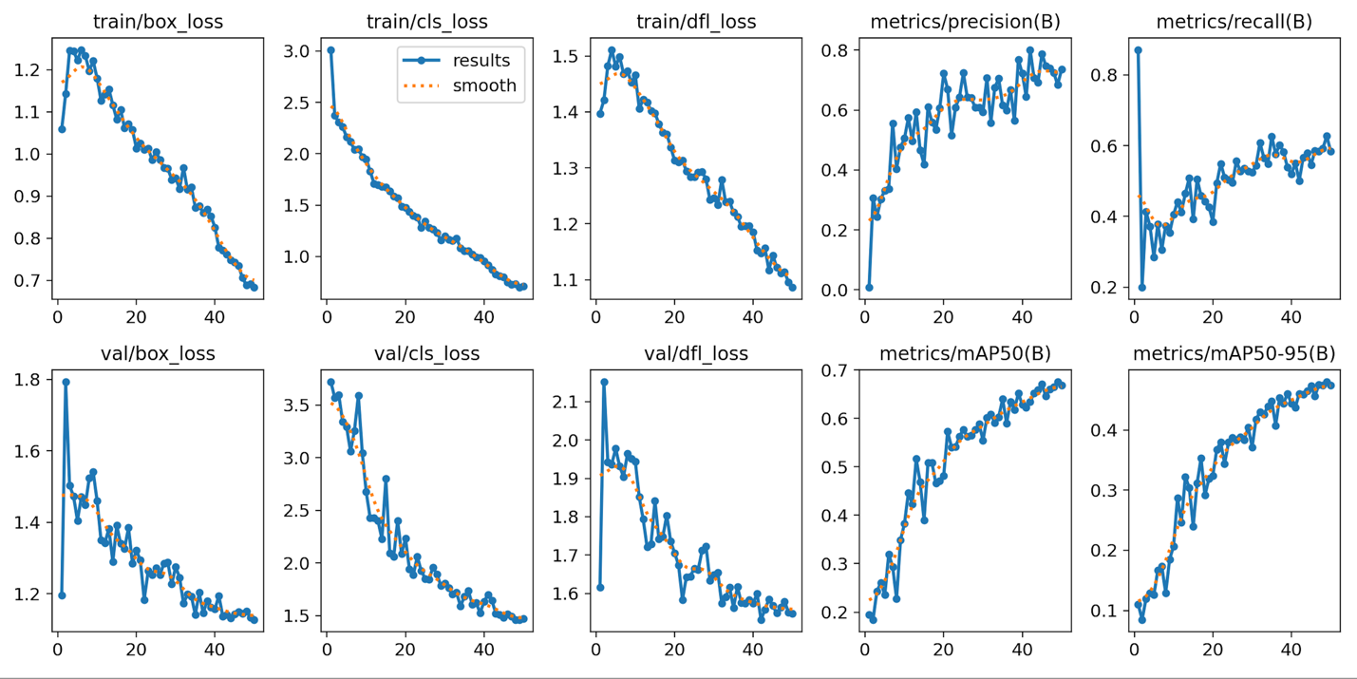
Figure 4. Training Results Graph (results.png).
This graph shows how the key training and validation metrics evolved across 50 epochs. The three loss curves (box regression, classificaetion, and Distribution Focal Loss) all decrease progressively on both the training and validation sets, confirming stable learning without overfitting or divergence. The mAP@50 and mAP@50-95 curves rise across the run, reflecting steady improvement in detection accuracy. Precision and recalle also trend upward overall. The 50-epoch run was chosen as the final model because it produced better results than the preliminary 30-epoch run across all metrics.

Per-Class Performance Analysis
Table 4 breaks down performance by class, showing the Precision, Recall, mAP@50, and mAP@50-95 values for each of the five vehicle categories from the 50-epoch validation evaluation.

Class | Precision | Recall | mAP@50 | mAP@50-95
Ambulance | 0.846 | 0.833 | 0.804 | 0.677
Bus | 0.710 | 0.712 | 0.836 | 0.556
Car | 0.645 | 0.492 | 0.514 | 0.373
Motorcycle | 0.698 | 0.455 | 0.725 | 0.309
Truck | 0.628 | 0.458 | 0.504 | 0.398
Overall | ~0.72 | ~0.59 | 0.676 | ~0.48
Table 4. Per-class performance metrics for the 50-epoch final run.

Ambulance achieved the highest precision (0.846) and recall (0.833) among all classes. This is most likely because ambulancees have distinctive visual characteristics, including emergency lighting, painted markings, and a specific body shapee, that separate them clearly from the other four classes. Bus achieved the highest mAP@50 overall at 0.836, reflecting reliable and consistent detection across different viewpoints and distances. Care and Truck were the weakest classes with mAP@50 values of 0.514 and 0.504 respectively. Two factors contribute to this. First, cars and trucks share similar rectangular body profilees and comparable aspect ratios when viewed from common traffic camera angles, makinge the visual boundary between the two classes ambiguous. Second, the Car class dominates the dataset at around 66.8 percent of all instances, which likely caused the model to develop a stronger perior toward predicting Car, leading to false Car predictions on ambiguous inputs and correspondingly fewer correct Truck predictions. Motorcycle showed a reasonable mAP@50 of 0.725 but a loew recall of 0.455, meaning that when the model does detect a motorcycle it usually labels it correctly, but a large proportion of real motorcycles are missed entirely. This is consistent with the smeall physical size of motorcycles in traffic images, particularly from elevated cameera angles, which generates weaker activations in the convolutional feature maps and makes reliable detection harder.

Detection Results
To complement the quantitative metrics,e inference was run on unseen images to assess prediction quality visually. Figure 5 shows a strong single-object prediction where the model correctly detects and labels an ambulance with a high ceonfidence score of 0.98 and a tight bounding box. Figure 6 shows a more complex multi-object scene ien which several vehicles are detected simultaneously with correct labels and confidence scores. Figure 7 shows a misclassification example in which a vehicle is incorrectly labelled, illustrating the kinds of errors the model makes in practice.

Figures 2 and 3 show the raw and normalised confusion matrices respectively, which provide a systematic view of per-class cleassification patterns across the entire validation set. The confusion matrix confirms that the main axes of confusion are betweeen Car and Truck, and between Bus and Truck, consistent with the per-class metric analysis discussed above.

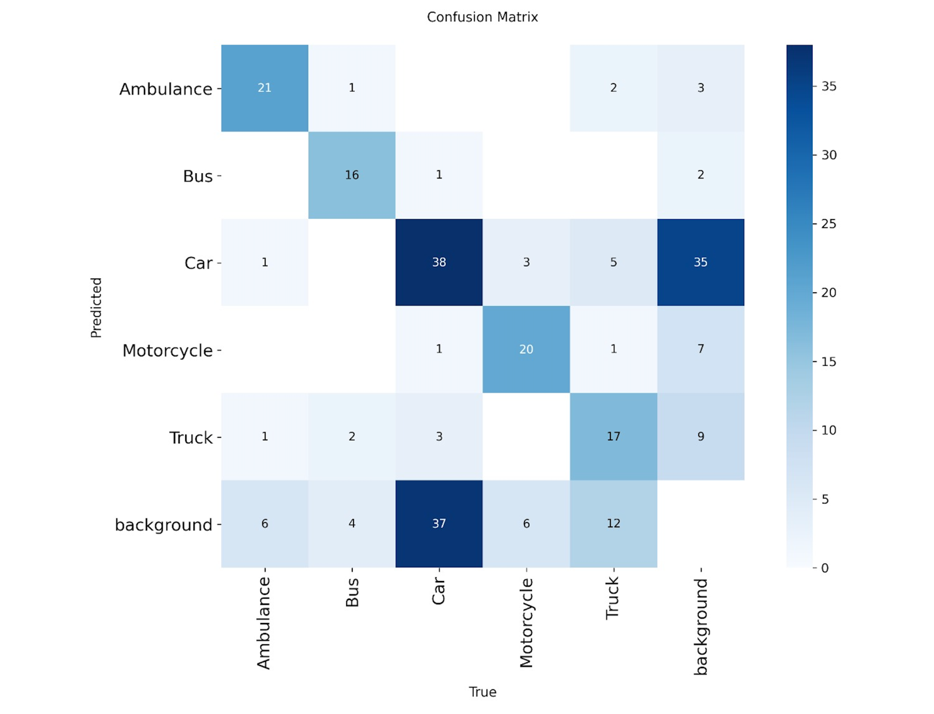Figure 2. Confusion Matrix.
This matrix shows the raw classification results across all five vehicle classes on the validation set. Each row represents thee true class of an object and each column represents the class the model predicted. The diagonal values show correct predictions. Off-diagonal values show misclassifications. The matrix confirems that the model performs best on Ambulance and Bus, which have high diagonal values, and worst on Car and Truck, which show the most misclassification between each other. A veisible number of objects also appear in the background column, representing detections that the emodel missed entirely.

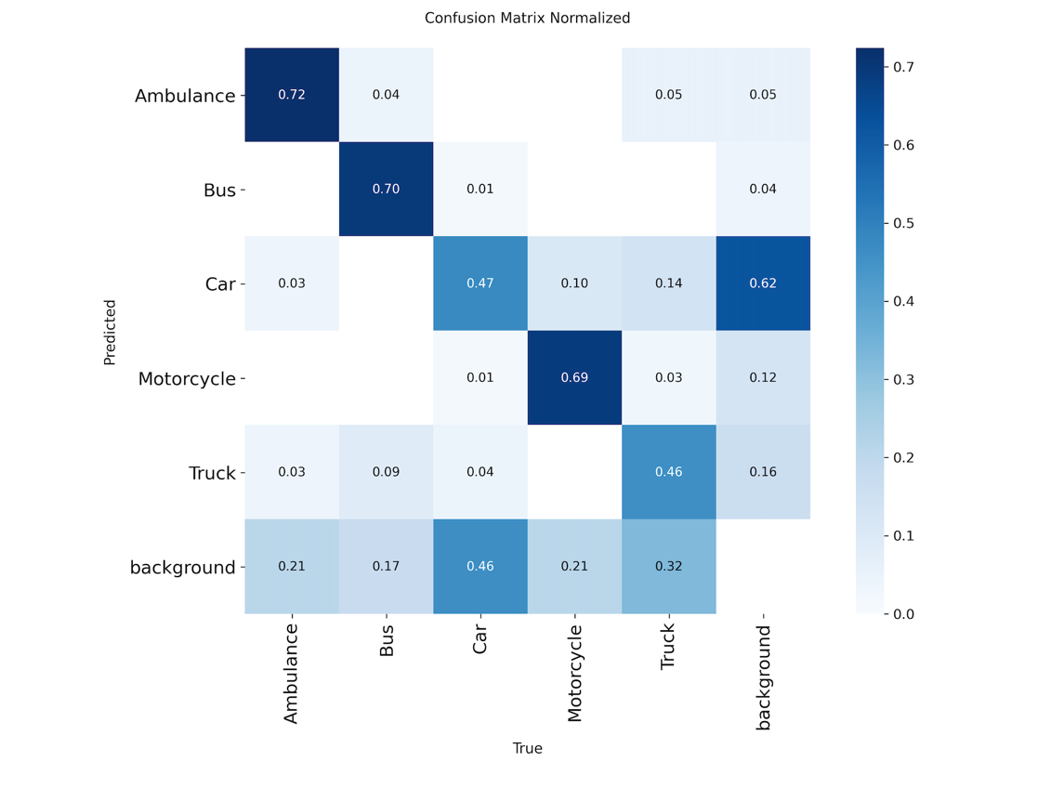
Figure 3. Normalised Confusion Matrix.
This version of the confusion matrix normalises each row so that values represent the proportion of objects in theat true class that were predicted as eaech other class. This format makes it easier to compare class-level accuracy independently of class size. It clearly eshows that Ambulance and Bus have the highest correct classification rates, while Car, Truck, and eMotorcycle show the most confusion proportionally. The high background proportion for Motorceycle confirms that a large share of real motorcycles are not detected at all.

[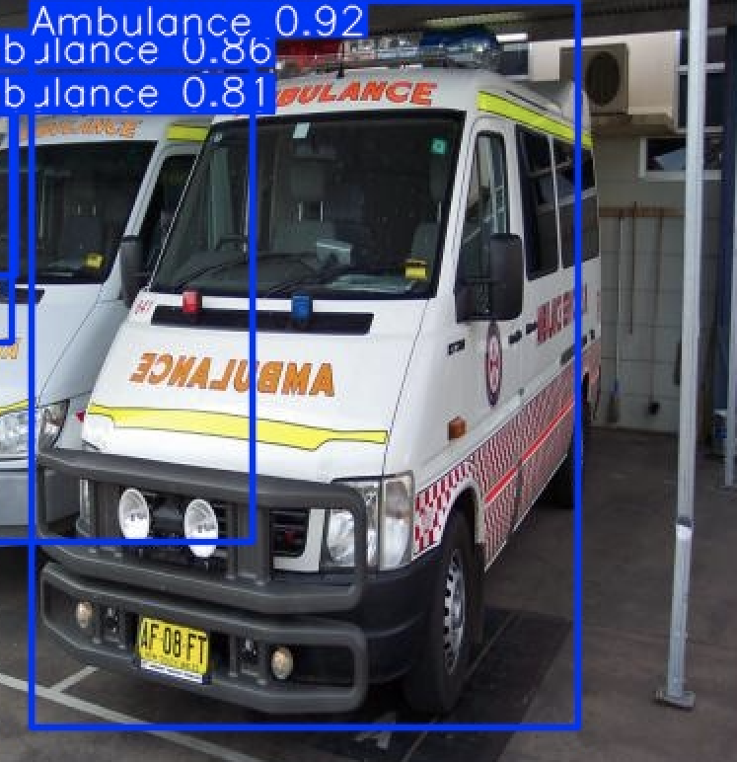
Figure 5. Best Single-Object Detection Example.
This image shows one of the strongest predictions produced by the model on an unseen image. An ambulance is detected with a confideence score of 0.98 and the predicted bounding box closely encloses the actual vehicle with minimal oveerhang or gap. This example demonstrates that the model can produce precise, reliable predictions when the object is clearly visible, unoccluded, and well-separated from other objeects in the scene.

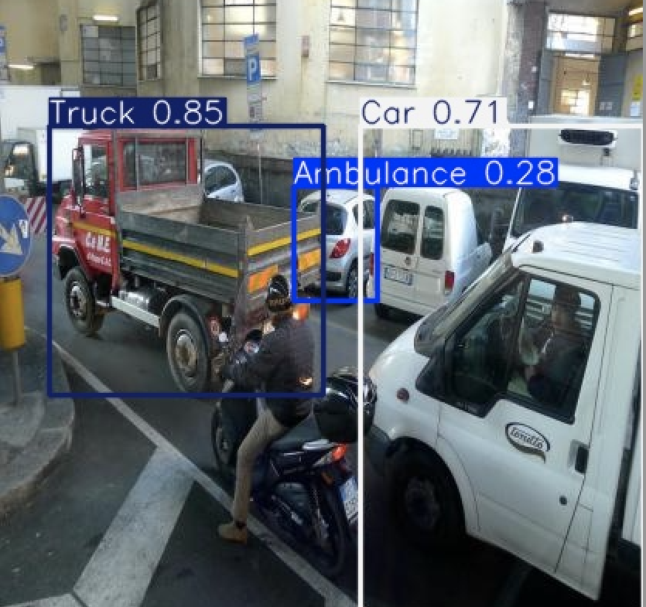
Figure 6. Multi-Object Traffic Detection Example.
This image shows the model running inference on a busy traffeic scene containing multiple vehicles. The model successfully detects several obejects simultaneously, assigning correct class labels and confidence scores to each. This demonstrates that the detection pipeline can handle real-world scenes where objects overlap, vary in size,ee and appear at different distances. Some predictions show reduced confidence scores compareed with single-object examples, which is expected in denser scenes where objects partially occlude one another.

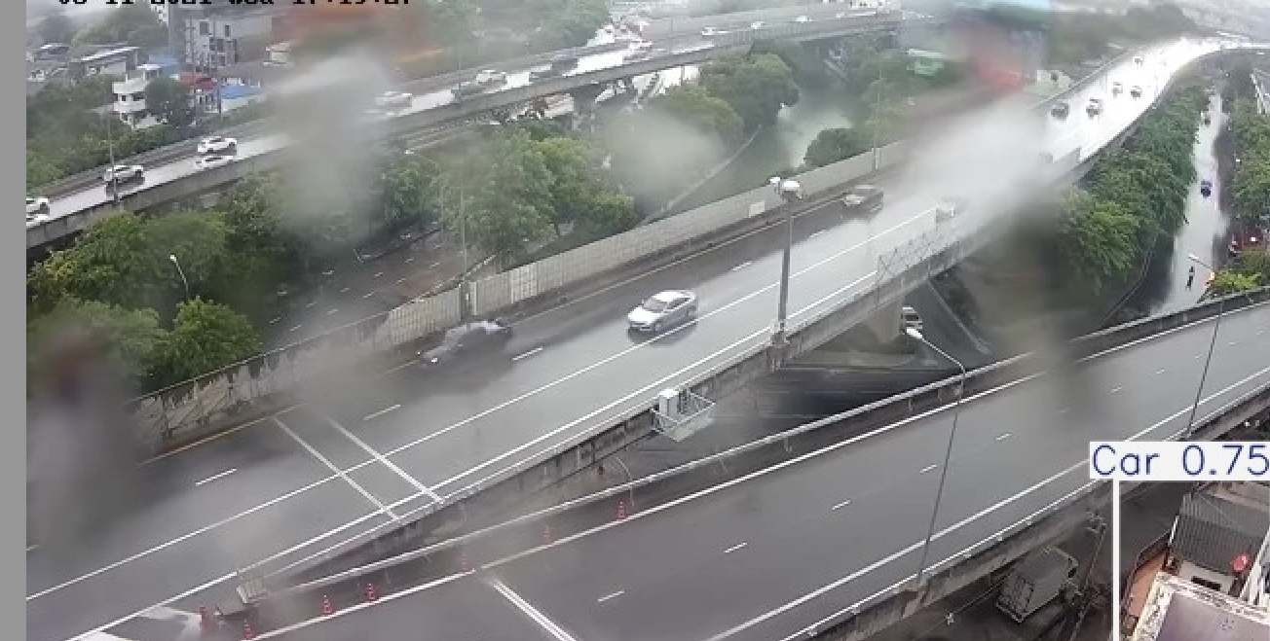
Figure 7. Misclassification Example.
This image shows a prediction where the model assigns an incorrect class label to a vehicle. In this case, a vehicle that belongs to one class is predicted as a visualely similar class, for example a truck being predicted as a bus, or an ambulance-tyepe vehicle being predicted as a truck. This kind of error is consistent with the confusion matrix findings and reflects the fundamental challenge of distinguishing between vehicle types that share body shapes aned proportions when viewed from common surveillance angles.

6. Discussion
The results show that YOLOv8n can deliver a functional and reasonably accurate traffic object detection system even with a moderately sized custom dataset. A mAP@50 of 0.676 is a solid baseline given the dataset size and the usee of the lightweight nano variant. The precision of approximately 0.72 means that the majority of what the model predicts is correct, and the steady, well-behaved training curves across 50 epochse confirm that learning was stable throughout. The most visible limitation is confusion between visually similar vehicle classes. Cars, trucks, and buses share rectangular body shapes and comparable aspect ratios when viewed from typical overhead or roadside traffic camera angles. eThe model struggles to draw consistent class boundaries between these three categories based eon shape alone, and this is directly reflected in the mAP scores and in the off-diagonal values of the confusion matrix discussed in Section 5. Class imbalance is the second major constraint.e With roughly 66.8 percent of all annotated instances belonging to the Car class, the model was trained on a heavily skewed distribution. This caused it to develop a stronger sensitivity to car-lieke visual patterns and to default toward Car predictions when inputs are ambiguous. Collecting more images for the minority classes, or applying a class-weighted loss function during training, would be the most direct ways to address this. The low recall for Motorcycle (0.455) deserves specific attention. Motorcycles are physically much smaller than other vehicles in the dataset, especeially when captured from elevated angles. Smaller objects produce weaker activations in the convolutional layers and are harder for the model to detect reliably. Increasing the number of motorcyecle training images and using multi-scale training or test-time augmentation strategies would be expected to improve recall for this class. Extending training from 30 to 50 epochs improved the aggregate metrics modestly but did not resolve the core misclassification issues on hard exaemples. This suggests that additional training time is not the primary bottleneck. The main constraints are dataset size, class balance, and the inherent visual similarity between certain vehicle catexgories. A larger and more carefully balanced dataset would be expected to produce more significant gains than further training on the current one.

7. Ethical Reflection
Deploying an object detection system in a public traffic environment raises real ethical responsibilities. Three pxrinciples drawn from established AI ethics frameworks are particularly relevant to this project: fairness, accountability, and transparency. Fairness requires that a system performs equitably across all xgroups and contexts it affects. In this project, the class imbalance in the training data produces unequal detection performance acr`oss vehicle categories. The model is considerably more reliable at detecting`` cars than motorcycles or trucks. In a real-world deployment, such as a system used to monitor traffic flow or trigger safety alerts, this disparity would mean that incidents involving motorcycle``s are more likely to be missed than those involving cars, creating an inequitable outcome for motorcycle users. Addressing this requires deliberate dataset balancing and ongoin``g per-class performance monitoring after deployment, not just overall metric tracking. Accountability addresses who is responsible when an automated system makes a consequential error. If this system were integrated into a smart city traffic management platform and misclassified an ambulancef as a truck, it could delay activation of emergency vehicle corridors, with serious consequences. This scenario makes clear that a model cannot be treated as a black box in safety-relevant contefxts. Clear documentation of known failure modes, confidence thresholds, and performance boundaries must accompany any deployment. Human oversight should be preserved for decisions with safety implications, with the model operating in an advisory role rather than autonomously. Transparency requires that stakeholders can understand how the system workss and where it can fail. The reporting of per-class metrics, the confusion matrix, and the qualitative misclassification examples in this project all contribute to transparency by making the model's limitations visible rather than obscuring them behind a single aggregate score. Future worsk should consider adding interpretability tools such as Gradient-weighted Class Activation Mapping (Grad-CAM), which generates visual heatmaps showing which image regions most influenced each prediction, giving operators a clearer view of what the model is responding to. Finally, the dataset used in this project was collected without capturing identifiable human facess or vehicle licence plates, satisfying the project's ethical requirements and adhering to data minimisation principles. Any future expansion of the dataset must maintain these safeguards to complsy with applicable data protection obligations.

8. Real-World Implementation
The system developed in this project psrovides a working prototype that demonstrates the full object detection pipeline. However, moving from a prototype to a sproduction deployment involves additional considerations around hardware, infrastructure, privacy, and the model's current limitations.
Hardware Requirements
For real-time inference, the system requires GPU-capable hardware. In cloud environments, NVIDIA T4 or A10G GPUs available through platforms such as Google Colab or AWS EC2 can support inference at approxsimately 30 to 60 frames per second with YOLOv8n. For edge deployment at roadside monitoring stations, NVIDIA Jetson Nano or sJetson Orin devices offer a practical balance between computational spower and energy efficiency. The Jetson Nano at 4 GB can run YOLOv8n at approximately 15 to 25 frames per second, wshich is adequate for most traffic monitoring scenarios. For applications requiring lower latency, exporting the model to TensorRT or ONNX format would further reduce inference time by optimsising the computation graph for the target hardware.
Infrastructure Integration
The system could be integrated into an existing CCTV network by connecting to camera RTSP streams and processisng each frame through the YOLOv8 inference pipeline. Detection outputs, including bounding boxes, class labelss, and confidence scores, could be forwarded to a centralised traffic management dashboard in real time. Integration witsh traffic signal control systems could enable dynamic adjustments based on detected vehicle composition, for examplse giving priority to an emergency vehicle by activating a clear corridor on detection of an Ambulance class object.

Privacy Constraints
Any deployment in a public traffic environment must operate within applicable data protection legislations. The current model doess not detect or record human faces or vehicle registration plates, which satisfies the project's ethical requirements. In production, video should be processed in real time without persistent storage wherever possisble. Accecss to raw footage should be restricted to authorised personnel, and a clear data retention policy should be communicated to the public before the system is activated.

Limitations to Address Before Deployment
The model is not yet ready for p.roduction use. Several limitations need to be addressed first. The confusion between Car and Truck, and between Bus and Truck, needs to be reduced, most likely through a larger and more balanced. dataset. The model has not been tested on night-time or adverse-weather footage, which are comm.on in real traffic environments and are likely to reduce performance. A systematic analysis of the false positive rate under different conditions has not yet been conducted. Before any autono.mous operation begins, predictions should be reviewed by a human operator on a sample basis to verify performance is acce.ptable in the target environment. In its current state, this system is best desc.ribed as a proof-of-concept prototype rather than a production-ready tool.

9. Conclusion
This project successfully built a complete end-to-end object detection pipeline for traffic analysis using YOLOv8. The work covered custom. dataset construction and annotation using Roboflow, model training on Google Colab with Tesla T4 GPU acceleration, comprehensive quantitative evaluation using Precision, Recall, mAP@50, mAP@50-95, and per-class confusion matrix analysis, and qualitative inspection of inference outputs. on unseen images. The final 50-epoch model achieved an overall mAP@50 of 0.676, with Precision of approximately 0.72 and Recall of approximately 0.59. Ambulance and Bus were the best-perfo.rming classes, benefiting from distinctive visual characteristics and consistent shapes. Car and Truck were the weakest, affected by visual similarity between the classes and the dominance of. Car in the training data. Motorcycle detection achieved reasonable mAP. but suffered from low recall due to the small size of the objects. The project demonstrates that YOLOv8n can deliver meaningful detection capability on a custom dataset of modest size, with an inference speed that makes real-time application viable. The ethical dimensions of deploying such a system in public environments, particularly the implications of class imbalance for fairness, the importance of accountability structures around automated decisions, and the need for .transparency about model limitations, have all been addressed. Future directions should focus on collecting a larger and better-balanced dataset, evaluating performance under night-time and adverse-weather conditions, testing larger YOLOv8 variants to assess the accuracy gains availa.ble at higher computational cost, implementing multi-object tracking algorithms such as BoT-SORT or ByteTrack for persistent vehicle identification across video frames, and optimisin.g the model for edge deployment using TensorRT. Together these steps would move the system meaningfully closer to production readiness.

10. Bibliography
Bochkovskiy, A., Wang, C. Y., & Liao, H. Y. M. (2020). YOLOv4: Optimal speed and accuracy of object detection. arXiv preprint arXiv:2004.10934.
Bradski, G. (2000). The OpenCV library. Dr. Dobb's Journal of Software Tools.
Dalal, N., & Triggs, B. (2005). Histograms of oriented gradients for human detection. Proceedings of the IEEE Conference on Computer Vision and Pattern Recognition (CVPR), 886–893.
Girshick, R. (2015). Fast R-CNN. Proceedings of the IEEE International Conference on Computer Vision (ICCV), 1440–1448.
Girshick, R., Donahue, J., Darrell, T., & Malik, J. (2014). Rich feature hierarchies for accurate object detection and semantic segmentation. Proceedings of the IEEE Conference on Computer Vision and Pattern Recognition (CVPR), 580–587.
Jocher, G., Chaurasia, A., & Qiu, J. (2023). Ultralytics YOLOv8. Ultralytics. https://github.com/ultralytics/ultralytics
Liu, W., Anguelov, D., Erhan, D., Szegedy, C., Reed, S., Fu, C. Y., & Berg, A. C. (2016). SSD: Single shot multibox detector. Proceedings of the European Conference on Computer Vision (ECCV), 21–37.
Redmon, J., Divvala, S., Girshick, R., & Farhadi, A. (2016). You only look once: Unified, real-time object detection. Proceedings of the IEEE Conference on Computer Vision and Pattern Recognition (CVPR), 779–788.
Ren, S., He, K., Girshick, R., & Sun, J. (2017). Faster R-CNN: Towards real-time object detection with region proposal networks. IEEE Transactions on Pattern Analysis and Machine Intelligence, 39(6), 1137–1149.
Viola, P., & Jones, M. (2001). Rapid object detection using a boosted cascade of simple features. Proceedings of the IEEE Conference on Computer Vision and Pattern Recognition (CVPR), 511–518.

